**Chapter 28: Gauss’s Law**

Table of Contents

28.1 Flux of the Electric Field 3

28.2 Gauss’s Law 5

28.3 Gauss’s Law and Coulomb’s Law 6

28.5 An Insulated Conductor 7

28.6 Gauss’s Law – Some Applications 8

Additional Resources:

<https://www.youtube.com/watch?v=yOv4xxopQFQ>

## 28.1 Flux of the Electric Field

Flux refers to the number of lines of force that cut through a particular vector field.





## 28.2 Gauss’s Law

The electric flux going through a closed surface is the sum of all charges inside the closed surface, divided by the permittivity of free space .

## 28.3 Gauss’s Law and Coulomb’s Law

For a point charge,

## 28.5 An Insulated Conductor

Since inside a conductor is zero, Gauss’s Law states that there can be no current inside it. If an additional charge is placed on this conductor, then the charge can only lie on the surface, not inside.

## 28.6 Gauss’s Law – Some Applications

Example 5:

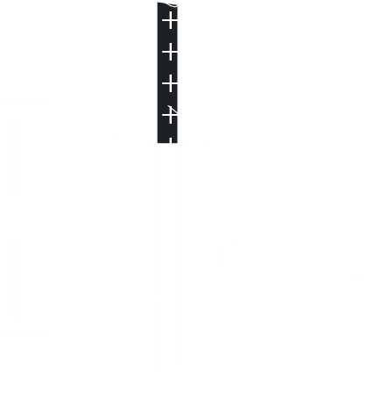

For a point above an infinite line of charge density , we must consider a cylinder as a gaussian surface.

Since the two ends of the cylinder are parallel to the electric field, there is no electric flux there. So .

Example 6:



For a point above a plane of charge density ,

Here, only the two ends are considered, since the curved surface is parallel to the direction of the electric field.

If two plates of equal but opposite charges are set parallelly, the electric fields outside cancel out, while inside, it doubles

So,